Learning Devops

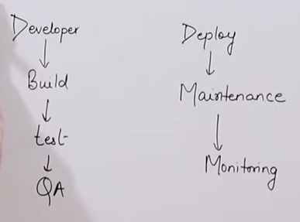

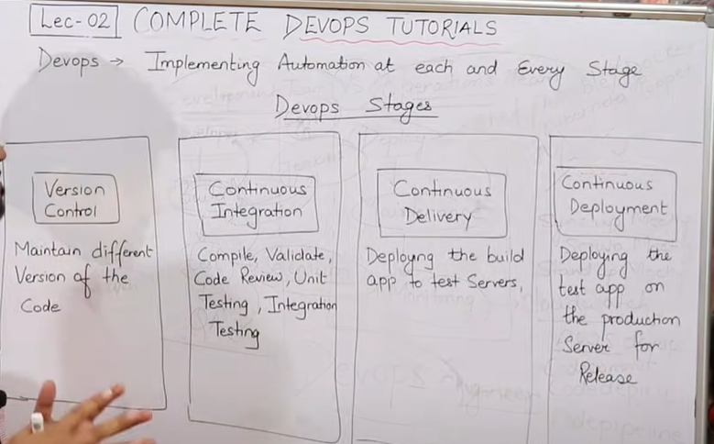

Access an AWS server with a key

Open puttygen ->load the private key downloaded from aws.->save the public key

Open Putty🡪add the ip then go to ssh->auth -browse the ppk file saved in last step

Append a file with >>

Concatenation of 2 files in a third file



Stat filename to get access time, modified time and change time

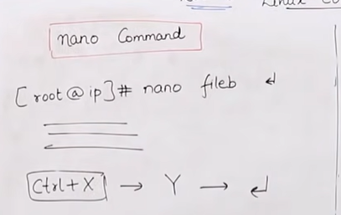

Empty a file with echo > <filename>

Yum list installed to show all installed packages

Cat /etc/passwd to check for any user on the system

Cat /etc/group to check for any group in the system

When user is created a group with same name gets created automatically but is not true when we add a group it does not create a user automatically

GPASSWD is used to add user to group -a for single user and -M for multiple users in one go

root@DESKTOP-238P215:/mnt/c/Users/RaviMALIK/Downloads/Downloads/prechecks# gpasswd -a karan ravi to add user karan to group name ravi

Adding user karan to group ravi

root@DESKTOP-238P215:/mnt/c/Users/RaviMALIK/Downloads/Downloads/prechecks# gpasswd -M abc,tanay ravi to add multiple users abc and tanay to group ravi

ln -hardlink used for backup keeps a copy of the original and keeps that updated with changes on original, changes done in original or backup fiel gets synchronized in other file

ln -s softlink its like a shortcut ln -s <original file> <softlink name/shortcut name>

TAR

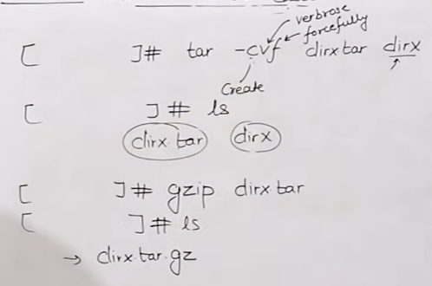

Tar is to group multiple files or bundle a directory that has nested dir and files/

Tar -cvf <dir or files to bundle> here c stands for compress

To untar the tar file use tar -xvf <tar file> here x stands for extract

Gzip to compress a tar file

Gunzip is read as g-unzip

Gunzip dirx.tar.gz and press enter to uncompress the zip file

Chmod u+x or u-x similarly g-rx or g=wx

Chown ravi file1

Chgrp syssap file1

Git

Ctrl+L cleares the screen as clear command

Git init converts a directory into a local repository

Add ->>to save the work doen in working directory to staging area

Staging to repo ->taking snapshot or saving the work

Local to github is done via push

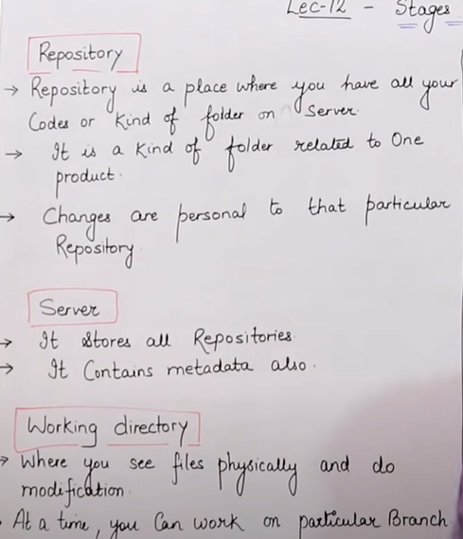

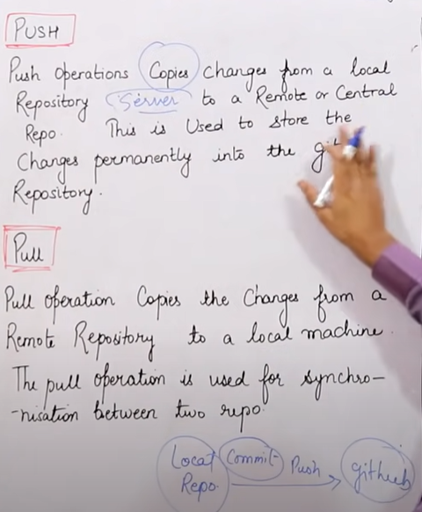

root@DESKTOP-238P215:/mnt/c/Users/RaviMALIK/Downloads/Downloads/prechecks/gitpractice# git --version

git version 2.34.1

root@DESKTOP-238P215:/mnt/c/Users/RaviMALIK/Downloads/Downloads/prechecks/gitpractice# which git

/usr/bin/git

root@DESKTOP-238P215:/mnt/c/Users/RaviMALIK/Downloads/Downloads/prechecks/gitpractice# git config --global user.name "ravi"

root@DESKTOP-238P215:/mnt/c/Users/RaviMALIK/Downloads/Downloads/prechecks/gitpractice# git config --global user.email "pune.ravi@gmail.com"

root@DESKTOP-238P215:/mnt/c/Users/RaviMALIK/Downloads/Downloads/prechecks/gitpractice# git config --list

user.name=ravi

[user.email=pune.ravi@gmail.com](mailto:user.email=pune.ravi@gmail.com)

